INTERESTED IN JOINING THE MILITARY SERVICE?

Students interested in enlisting with any of the Military Services should follow similar procedures for investigating and finalizing your decision of which branch to enlist with as do students searching for colleges. It is important that you understand all of the facts regarding enlistment in a United States Military Service.

All branches require that potential applicants take the Armed Services Vocational Aptitude Battery or A.S.V.A.B. The ASVAB Career Exploration Program is designed to help students: identify, understand, and organize information about their interests, abilities, and personal preferences. Determine which occupations best match their personal characteristics. Please call your recruiter for more details. It will be very important that you research the opportunities available to you by looking into all of the service branches and then deciding on only one service branch to enlist with, just as with any college search.

All Military Branches (Air Force, Navy, U.S. Army, Marine Corps, Coast Guard, Army National Guard and Reserves) have local representatives and make frequent visits to the high school. Visits are of two basic types – 1) General information meetings where recruiters will provide basic information and literature about their respective branches and 2) Individual appointments in school or at the home which must be arranged and approved by all parties; the recruiter, the school, the student, and the family. These happen on Mondays at CNS and must be pre-arranged through the Career Center. It is important that you continue to work with your guidance counselor while you investigate the possibilities of Military Service even though your recruiter may be providing all of the information required to successfully enlist with the Armed Services. Advanced notice of Military Service visits will be posted and announced the same way that college visits are listed. These occur during lunches from 10:31 – 12:35 on Mondays ONLY.

ROTC INFORMATION

http://www.bestcolleges.com/resources/rotc-programs/

RECRUITMENT CENTERS IN OUR AREA:
US Air Force  5671 E. Circle Drive  Cicero, NY 13039  (315) 458-4909  (315) 955-9921 (Cell)  (315) 458-5740 (Fax) | Marine Corps  372 Northern  Lights Plaza  North Syracuse,  NY 13212  (315) 455-2933  (315) 455-2771(Fax) | U.S. Army and  U.S Army Reserve  372 Northern  Lights Plaza  North Syracuse,  NY 13212  (315) 455-6669
NY Army National  Guard  6900 Thompson Rd  Syracuse, NY 13211  (315) 463-7242 | U.S. Navy  372 Northern Lights Plaza  N. Syracuse, NY 13212  (315) 455-1684 | Coast Guard  www.gocoastguard.com
NY Air National Guard  174 FW/DPMR  6001 East Molloy Rd  Syracuse, NY 13211  (315) 233-2139  1-800-TO-GO-ANG  (1-800- 864-6264)  www.goang.com | Army ROTC  380 Archbold North  Syracuse, NY 13244  (315) 443-1752  (315) 443-2462  armyrotc@syr.edu | Air Force ROTC  122 Lyman Hall  100 College Place  Syracuse, NY 13244  (315) 443-2461  afrotc@syr.edu
 | 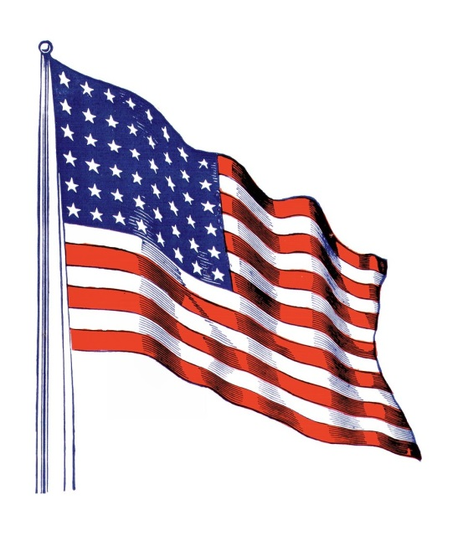
(updated on March 8, 2017)

