Computer Club Sign-Up Form
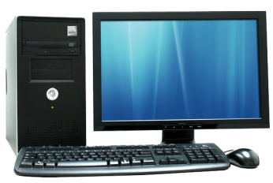

Come join us on Mondays, 3:10 – 4:15, after school to use Chromebooks, Google Docs, Word, Publisher, and PowerPoint!
We will meet once per week in the Computer Lab 137 near the LRC.

Fill out the form below and bring to first meeting on October 2nd

Club meets every MONDAY of each month.

Student Name (First / Last) __________________________________

Grade:_____________________

HR: _______________

EMERGENCY CONTACT NUMBER: ___________________________

My child will either:

_____ Take the late bus home or

_____ Be picked up at 4:10 by a parent

Child Signature___________________________ Date:________
Parent Signature__________________________ Date:________

