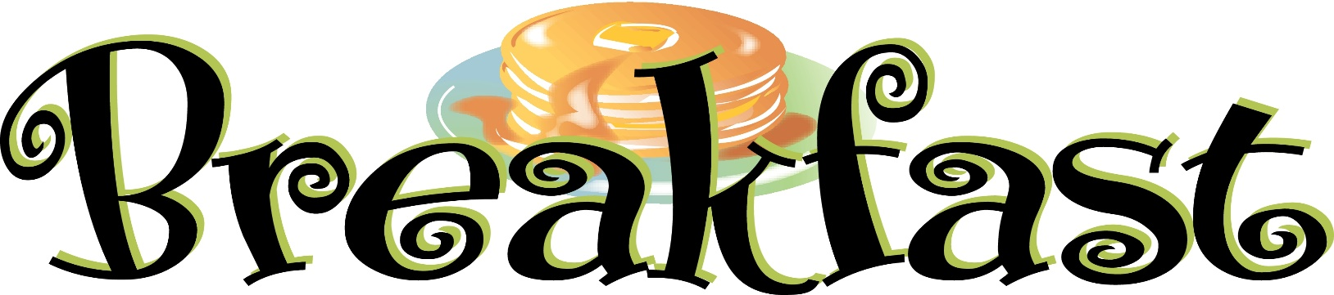
Summer Program Roxboro Middle School

Monday: Cereal Kits w/ Fruit and Milk
Tuesday: Banana Bread or Assorted Muffins w/ Assorted Fruits and Milk

Wednesday: Cereal Kits w/ Fruit and Milk

Thursday: Mini Pancakes or Waffles, Assorted Fruits and Milk

Friday: Whole Grain Donut Holes w/Assorted Fruits and Milk
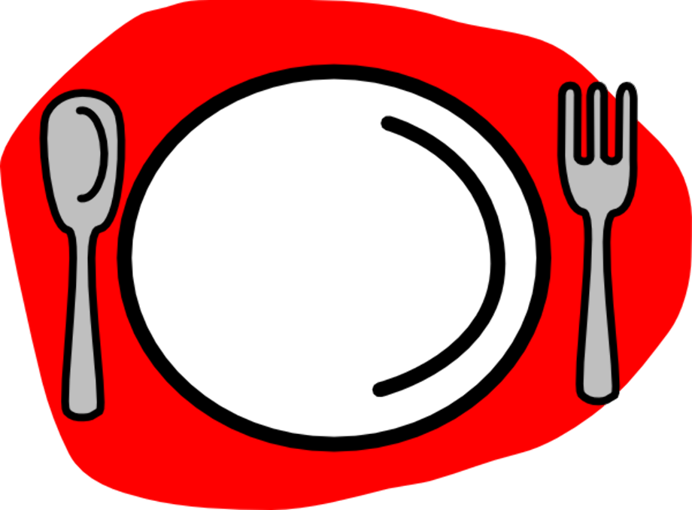
Other items available daily:
Pop tarts and Cereal Bar Kits
Menu Subject to Change
All meals served with a choice of juice, fruit and milk.

North Syracuse School District is an equal opportunity employer and provider.

